Greetings Respected Customers,
We firstly thank you for purchasing this App and we sincerely hope it brings value to your purchase. Please take 5 minutes each to read this Document and our Product Agreement before proceeding installation and App Execution. This is mandatory for proper execution and understanding of this App and a pre cursor for every purchaser of this App.

This App enhances the browsing experience by providing better speed and connectivity.
It uses eclectic technology to tweak internal settings and optimize browsing experience.
This App can be purchased with lifetime License, however we plan to provide periodic upgrade versions(currently tentatively planned once a year or so) that can be purchased in future at a suitable price. Hence please check our website periodically.
This App can be used with Broadband or 2g/3G/4G Mobile Internet Hotspot(Tethered to Windows Home OS. 10 or 11) connection on Windows 10 and above only Laptops/Desktops[Tested on Windows 10 & 11 Home Only]. You need to have Microsoft Dot Net Framework 5.0 installed in your machine upfront (dotnet.microsoft.com).
App Launching – Precautions.
The App can be launched from the Installed folder. Although it is tested successfully, it is recommended for your system safety that you create a System Restore point before launching the App.. In the unlikely event if something goes wrong in your computer, you can always restore back to original state.
Please follow the below steps.
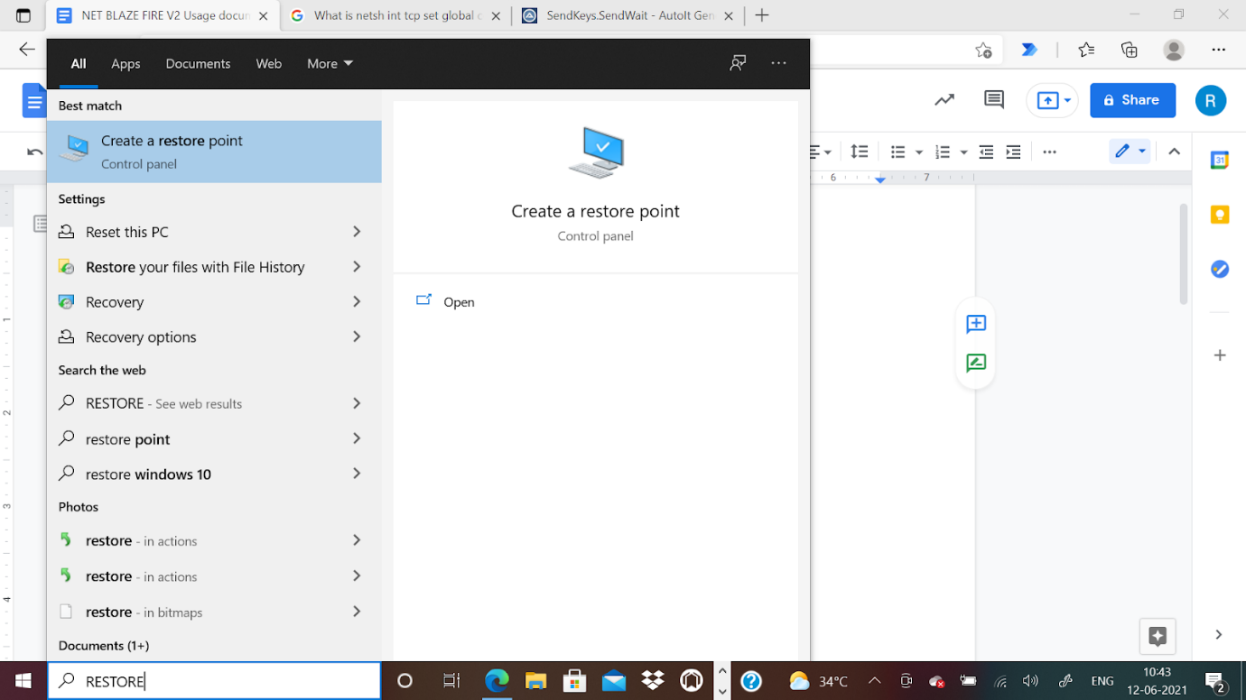

- Create Restore Point-

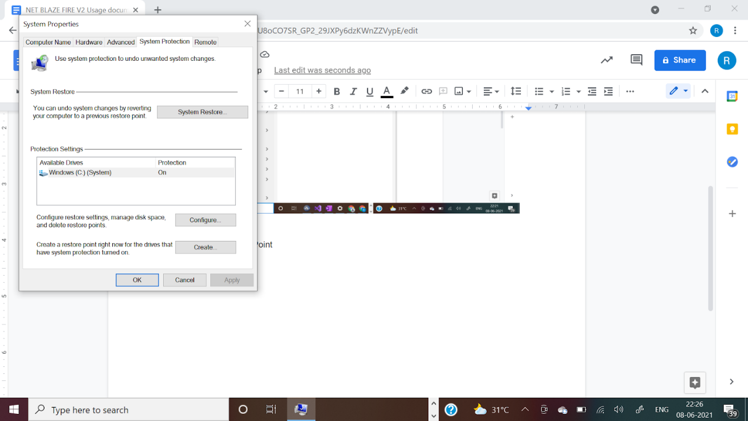

- Select Create
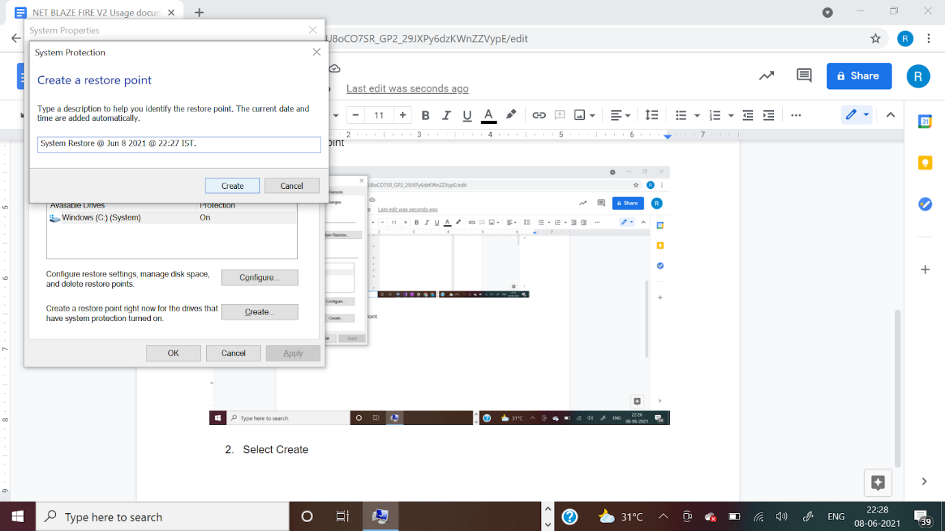

- Give a suitable name for the restore point and Create it.
Then Proceed for Installation & App Launch
- Download the Software from the Provided Link/emailed to you; Unizip it(if applicable) and install it into the system.(Preferably/Recommended).
- Then Double click on the Application File with our Blue logo – Net Speed Blaze Fire File, Furnish the Provided License key in the App and click the Launch button and then observe the computer screen for instructions through the execution.
We request you not to make any Keyboard press or mouse movements(except for UAN Popup window acceptance immediately after it appears) after launching App until App execution completes

- Please accept the UAC.(User Account Control window popup) where applicable(twice) as soon as it appears in the screen(Immediately).
- License Check happens automatically, however License Key has to be keyed in when Prompted. (You will be providing us some basic system data like your Computer Name and Primary Mac Address, for us to provide you the Software and License.)
- Wait for the App to complete execution(Idling). Usually it takes under 1-2 minutes.
- After execution success message, kindly restart your Computer for the changes to effect.
- We hope now you experience an enhanced browsing experience.
- In the worst case, if you feel that you are finding any concerns/errors in your
Computer after the App usage and system restart, please revert to the Restore Point you created before the App Usage and if still any error persists, please reach your nearest Computer service centre.
This App can be run as needed for performance and this License is valid for Lifetime, however we are tentatively planning for future upgrades.
- The App has been successfully tested in Windows 10 & 11 Home edition.
12. You can provide your feedback/clarification/concerns on this App at www.altatechbiz.com; via Email : altatechbiz@altatechbiz.com or via our Contact Page

Installation & Launch
Follow the installer package instructions to install the App. You can find the App launcher in the Installed folder(please note this path during installation) and also in the Program Menu Bar in Windows (can be used for Uninstallation later as well).
Please install the App in the desired install location folder and then install by following onscreen instructions.
After installation, go to the installed folder path and double click on the file – Net Speed Blaze Fire – www.altatechbiz.com – ALTA TECHBIZ (Application type file with our Logo in near Blue colour).
Now key in the provided License and carefully follow the onscreen instructions for proper App execution.
To summarise; notes/Terms:
We(ALTA TECHBIZ) will not be responsible for any of the non performance or adverse consequences while using this App., due to any reasons. Please be noted that we have successfully tested this App at our end on Windows 10 & 11.
Additionally, this App can be used as and whenever there is a need, however better results are seen when there is a longer duration between each use (say atleast 3-5 days).

- There is no refund policy of any nature and ALTA TECHBIZ will not be liable for any consequential damage of any nature as a result of usage of this App. Please read Terms and Conditions. Any inconvenience is regretted, however ALTA TECHBIZ, believes & strives for happy customers, Please be noted that the customer needs to try the product a few times spread over at least 2-3 days to see good results. The performance may vary, each time the product is used.

- We process only limited orders per day and the additional requests may take some time for delivery. Any inconvenience is regretted. Please confirm with us upfront via Contact Us/Reach Us Page. Please expect delay in response.

- Purchase can be made via our website - www.altatechbiz.com using the Product Page ; available in the link. There may be some delay in our response communication to you depending on work volume, and your patience is appreciated.

- This software License product needs to be purchased for every unique PC/Laptop.

- Please ignore any Virus or harmful file notification during download. This product is safe and tested with Anitivirus tools as shown below.

Screenshots : With Windows Defender Security & McAffee Total Antivirus
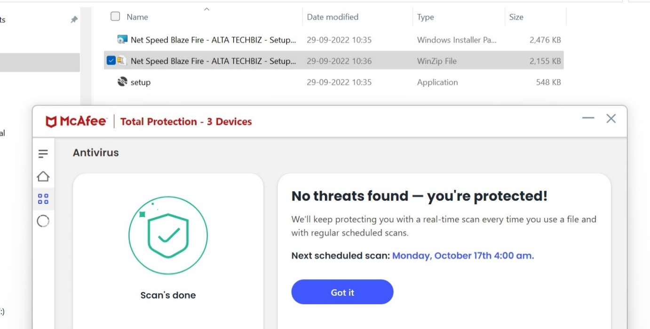

- We thank you for your patronage towards ALTA TECHBIZ and its Products.

Sample Test Results - Tested on below specification of Device and Operating System. :
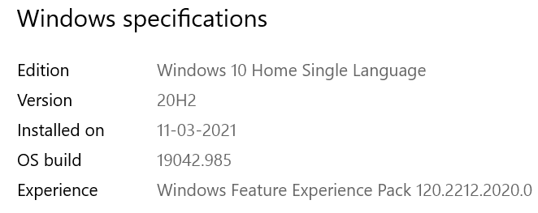
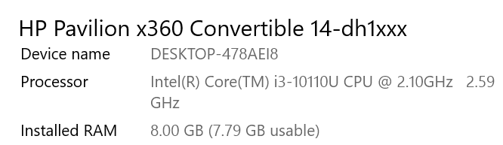

Pre App Usage - Internet Speed Test Sample from a 4G. Internet Data Connection: Speed Test App.

From : Ookla Speed Test website - https://www.speedtest.net/

Sample 1 – Before App usage [Net Speed Blaze Fire – ALTA TECHBIZ]
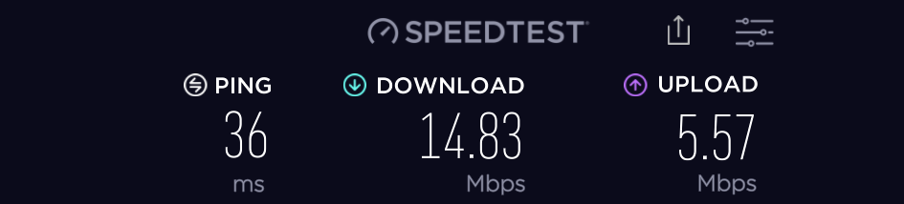

Sample 1 – After App usage [Net Speed Blaze Fire – ALTA TECHBIZ]
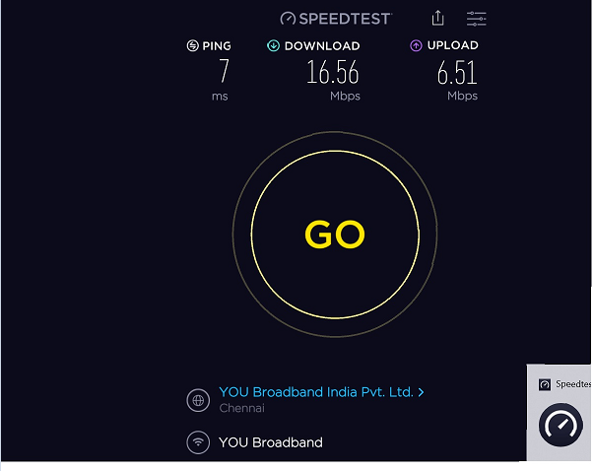
Post App Usage - Internet Speed Test Sample from the same 4G Internet Data Connection provider and Speed Test App as above.
This is after Computer Restart :

Sample 2 - Sample 2 – Before App usage [Net Speed Blaze Fire – ALTA TECHBIZ]

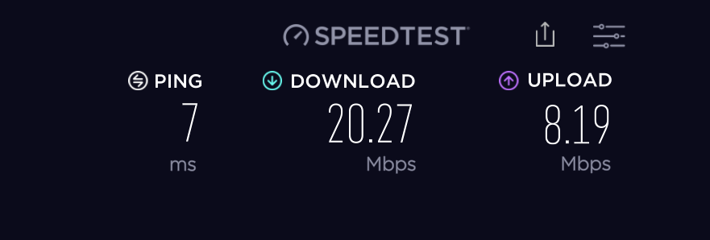

Sample 2 – After App usage [Net Speed Blaze Fire – ALTA TECHBIZ]
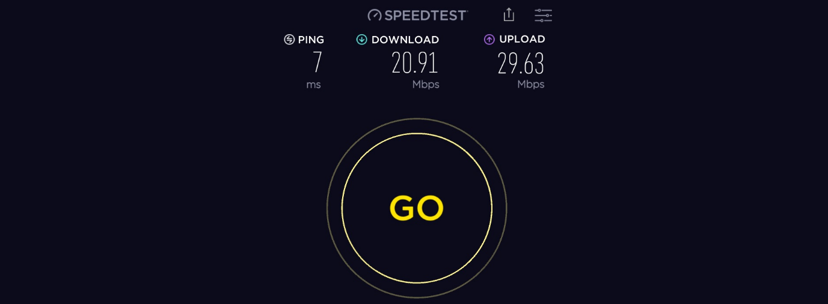

The above test result was taken within 5 minutes of App usage after Restart with 2 iterations.
Test Results may vary and are subjective to many parameters(some beyond the control of this App).

Note:
- Sometimes a few repeated tests over a span of time may yield desired results.
- It is also assumed that the Purchaser enters the Master Product Agreement on Purchase of this Product.
- Although the App is tested thoroughly for positive results, we will not be responsible for any non performance or adverse consequence for using this App.

